| Semester | T.E. Semester V I– Computer Engineering |
| --- | --- |
| Subject | Cryptography and System Security |
| Subject Professor In-charge | Prof. Amit K. Nerurkar |
| Assisting Teachers | Prof. Amit K. Nerurkar |
| Laboratory | 312B |

| Student Name | Deep Salunkhe |
| --- | --- |
| Roll Number | 21102A0014 |
| TE Division | A |

**Title:**

**Breaking the Shift Cipher**



**Explanation:**

**A private-key encryption scheme consists of a set of all possible messages, called the message space M, and three algorithms, namely,**

**(a) Gen**

**(b) Enc**

**(c) Dec**

**The algorithm for key generation Gen is used to choose a key k at random from the set of all possible secert keys, denoted by the key space K.**

**The algorithm for encryption Enc takes as inputs the message m and the secret key k and outputs the ciphertext c.**

**The algorithm for decryption Dec inputs the ciphertext c and the key k and outputs the message m.**

**About the experiment:**

**Apparently, the system is easily broken if the total number of distinct secret keys is small, that is the key space K is small.**

**In this experiment, we work with a well-known historical encryption scheme, namely the shift cipher, that has a very small key space.**

**Your task is to break the shift cipher. Specifically, given (only) the ciphertext in some instance of a shift cipher, you need to find the plaintext and the secret key.**

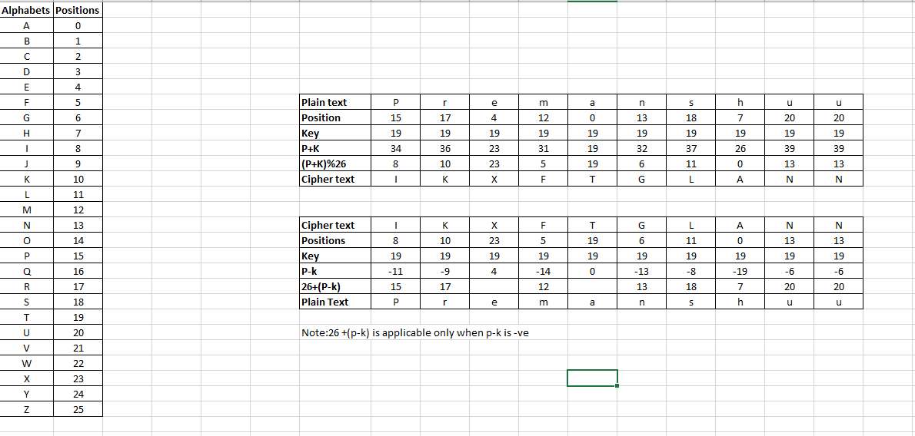

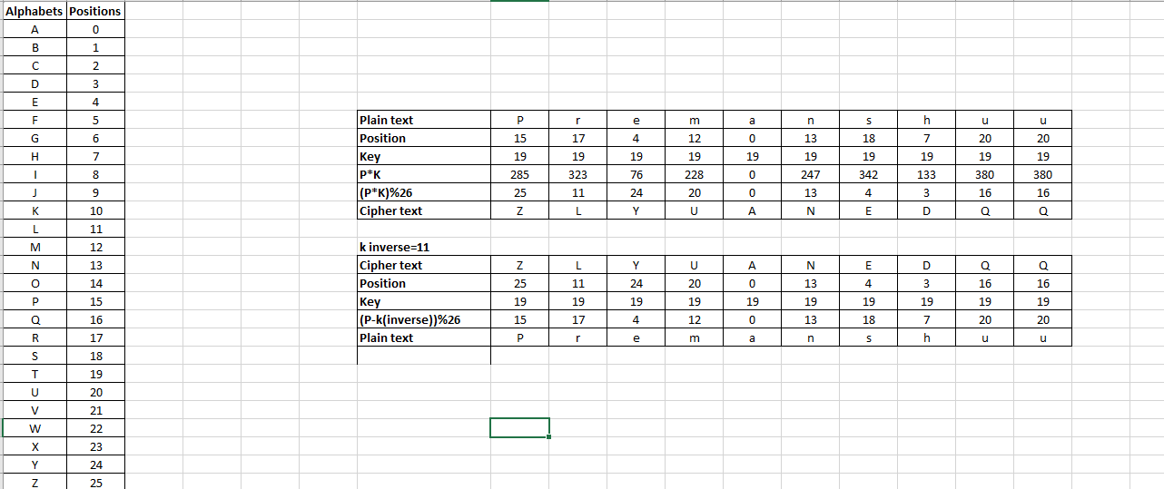



**Simulation:**

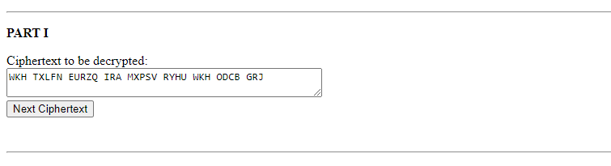

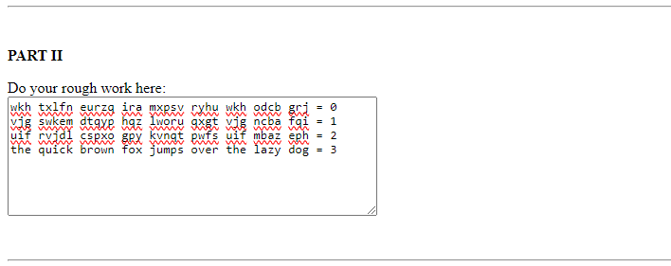

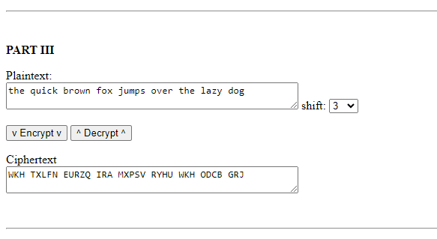

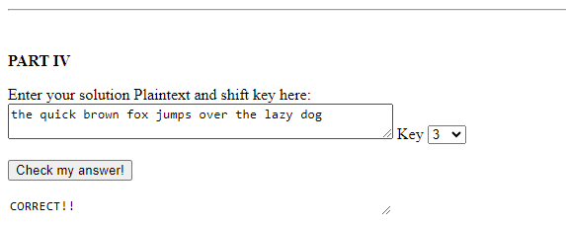



**End Result: –**



**Conclusion:**